Name:ahmed atef ahmed

Bn:77

Title project: programming languages

GITHUB LINK: <https://github.com/Ahmedatefahmed/ECE001>

GITHUB page (puplish web site) <https://ahmedatefahmed.github.io/ECE001/uses%20of%20programming%20languages.html>

Application brief: Computer programming language, that is, from any of the different languages to express a set of detailed instructions for a digital computer. These instructions can be implemented directly when they are in the computer manufacturer's digital form known as machine language, after a simple replacement process when they are expressed in a corresponding assembly language, or after translation from some "top-level" language. Although there are many computer languages, relatively few are widely used

These languages make computers process big and difficult areas of information quickly and efficiently. For example, if a person is given a list of random numbers ranging from one to ten thousand and asked to arrange them in ascending order, it might take a lot of time and include some errors.

There are large number of programming languages used in the industry today. We have compiled overviews of the 12 most important, important, and most requested of these languages below

Screen shots:

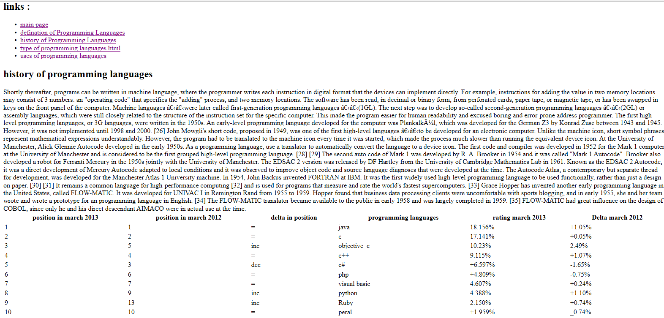

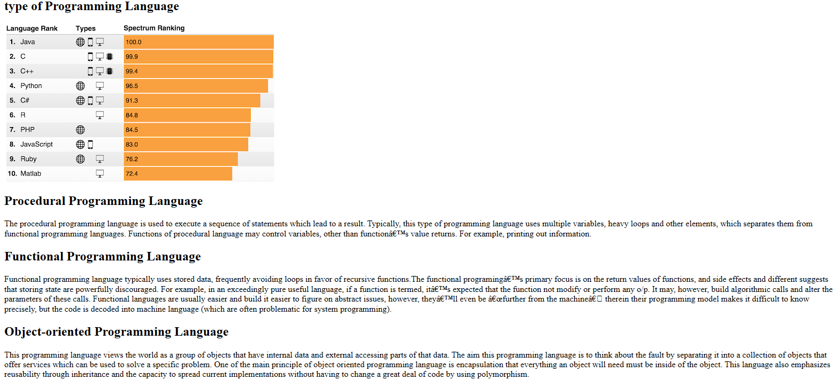

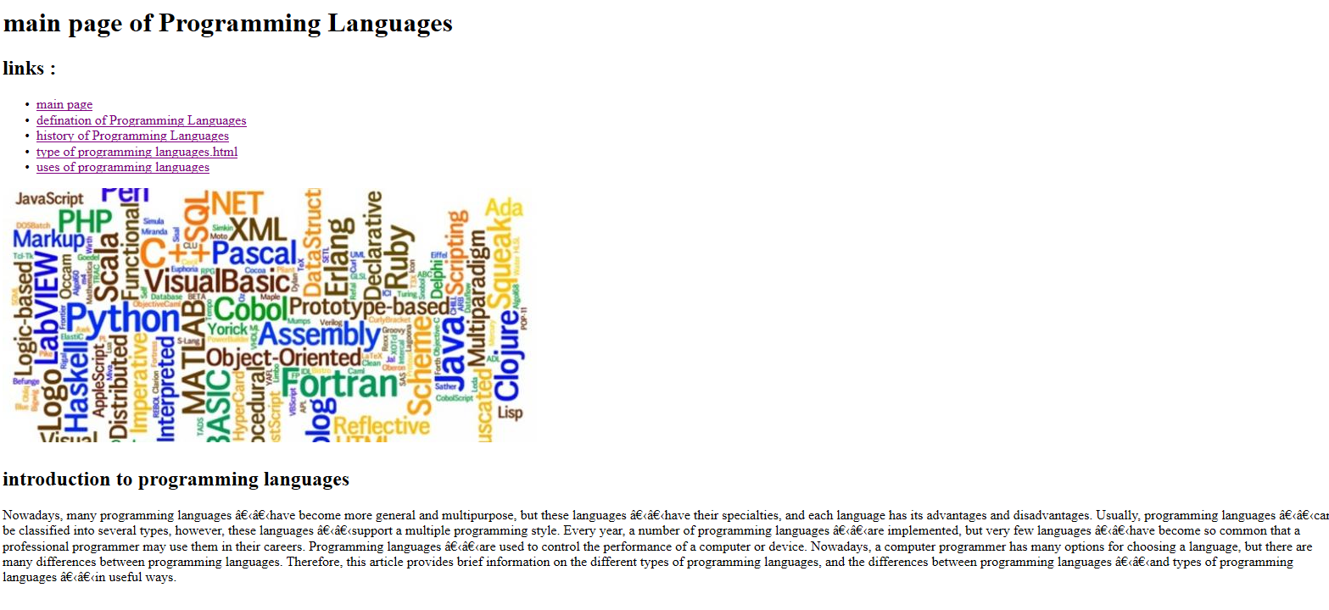

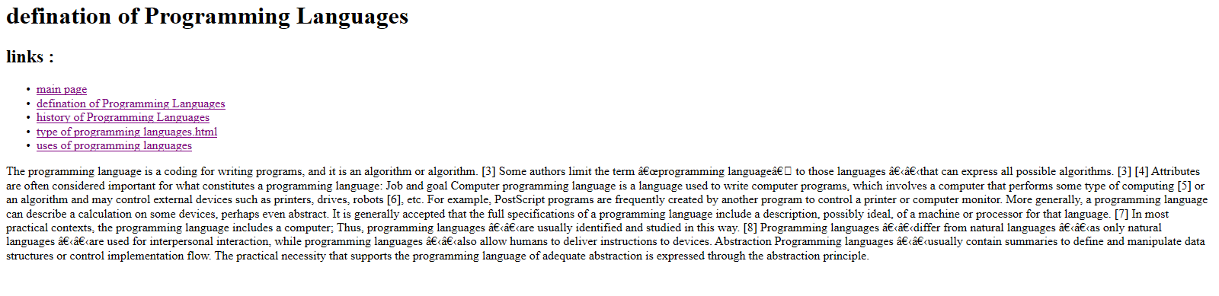

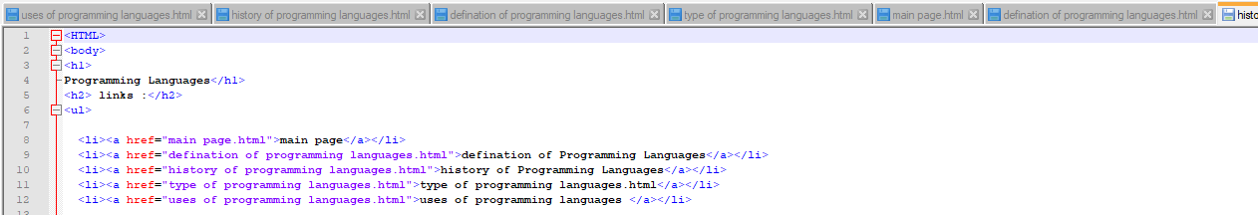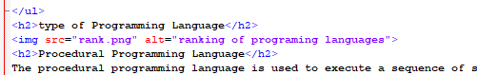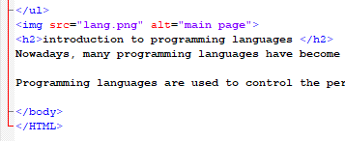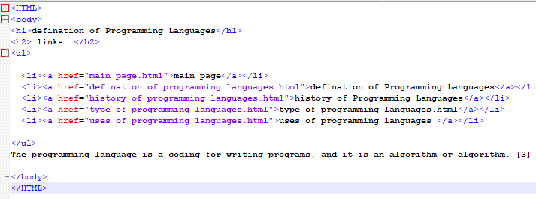**Source code:**

